Section A - Horses in Action & Breed
Saturday, 27th September 2025

Affiliated ACS of SA & Federal Council of Agricultural Societies
Start Time: 9.00am- Gate Opens: 6.00am

MEMBERSHIP is Compulsory: Horse Section - $30 (2 Adult + 2 Children)
Single Membership- $12
ENTRIES CLOSE: Wednesday 24th September 2025

Rings 1 & 2: Royal Qualifying - Show Hacks & Hunter
Ring 5: Tiny Tots & Open Encourage - Fancy Dress

Breed Rings
Ring 3: Riding Pony Program, Australian Pony Stud Book General Program,
Welsh Pony & Cob Society Program & ThoroughCare SA (Led & Ridden) Program
Ring 4: Miniature Pony High Point Program, Pinto Program, Open Breeds & Arabs SA Program

***FANCY DRESS AT COMPLETION OF ALL RINGS-OPEN TO ALL COMPETITORS***

ENQUIRIES: Emily Foale-Jacka 0437 916 411 or emilyfj94@gmail.com

RULES AND INFORMATION

• Exhibitors, Owners, Riders and Handlers must have Balaklava Show-Horse Section Membership.
• PLEASE NOTE: Competitors in BREED Rings 3 & 4 may be asked by RING STEWARD to present a MEMBERSHIP CARD and EXHIBITS REGISTRATION PAPERS for their respective breed classes before they will be allowed to compete.
• Age of rider's are as they are on the day of competition.
• Oval Safety Regulations insist that at no time ponies or horses be tied to oval fence or fixtures.
*No Horses allowed on Cricket Pitch.
• Any competitor whose failure to comply with directions from Horse Committee may result in disqualification from the competition.
• LUNGING HORSES MUST BE KEPT MOVING AROUND OVAL *Not in one spot!
• Protests must be lodged within 20 minutes of completion of the event together with $50.00.
• Approved safety Helmets must be worn at ALL TIMES while mounted, boots must be worn while riding and Handler must wear covered flat or low heel Shoes.
• Competitors in RQ RINGS 1 & 2 must compete as a SHOW HACK or SHOW HUNTER not both.
• Swabbing may occur at this Show.
• Entry Forms will not be received without payment!
• No Entrance Tickets Posted! Exhibitors Name will be checked at Horse Gate on arrival!
• NO DOGS ALLOWED.
• JUDGES DECISION IS FINAL

ALL HAY & MANURE TO BE PUT IN SUPPLIED BINS-PLEASE KEEP YOUR AREA TIDY.PARKING IS TIGHT SO PLEASE BE MINFUL WHEN SELECTING A PARKING SPOT.

There will be a SUPREME RIDDEN EXHIBIT in Rings 1 & 2 also a SUPREME LED
EXHIBIT in Rings 3 & 4 to be judged at the completion of judging in all Rings
Winners will receive a SASH & PRIZE
Open Royal Qualifying - RING 1
Judge: Erin Bradshaw
RING STARTS: 9.00 am

Class 7101 Open Show Galloway Hack over 14hh ne 14.2hh
Class 7102 Open Show Galloway Hack over 14.2hh ne 15hh
Class 7103 Lightweight Galloway Hack over 14hh ne 14.2hh

Class 7104 Lightweight Galloway Hack over 14.2hh ne 15hh
Class 7105 Heavyweight Galloway Hack over 14hh ne 14.2hh
Class 7106 Heavyweight Galloway Hack over 14.2hh ne 15hh
Class 7107 Childs Show Galloway Hack over 14hh ne 15hh
Class 7108 Ladies Show Galloway Hack over 14hh ne 15hh
Class 7109 Gentleman's Show Galloway Hack over 14hh ne 15hh
Class 7110 Open Show Galloway Hack over 14hh ne 15hh
CHAMPION SHOW GALLOWAY HACK
RESERVE CHAMPION SHOW GALLOWAY HACK
**Sponsored by On Top Roof Restorations**

SHOW HACK
Class 7111 Open Show Hack over 15hh ne 15.2hh
Class 7112 Open Show Hack over 15.2hh ne 16hh
Class 7113 Open Show Hack over 16hh ne 16.2hh
Class 7114 Open Show Hack over 16.2hh
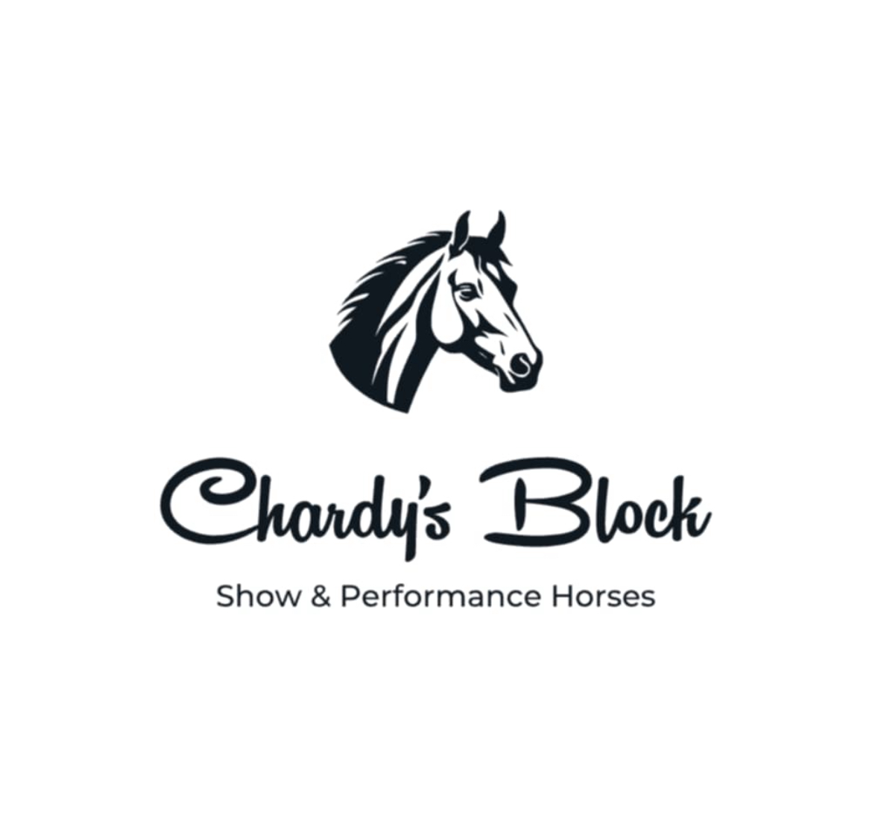
Class 7115 Lightweight Hack over 15hh ne 16hh
Class 7116 Lightweight Hack over 16hh
Class 7117 Heavyweight Hack over 15hh ne 16hh
Class 7118 Heavyweight Hack over 16hh
Class 7119 Childs Show Hack over 15hh
Class 7120 Ladies Show Hack over 15hh
Class 7121 Gentleman's Show Hack over 15hh
Class 7122 Open Show Hack over 15hh ne 16hh
Class 7123 Open Show Hack over 16hh
CHAMPION SHOW HACK
RESERVE CHAMPION SHOW HACK
**Sponsored by Chardy’s Block Show & Performance Horses**

SENIOR RIDER
Class 7124 Rider 18 years and under 21 years
Class 7125 Rider over 21 years

Viceban Homes
CHAMPION SENIOR RIDER
RESERVE CHAMPION SENIOR RIDER
**Sponsored by Viceban Homes**

SHETLAND PONY
Class 7126 Childs Shetland Pony ne 10.2hh, Rider 3 years and under 12 years
Class 7127 Shetland Pony ne 10 hh
Class 7128 Shetland Pony over 10hh ne 10.2hh

The Fricker Family
Class 7129 Open Shetland Pony ne 10.2hh
CHAMPION RIDDEN SHETLAND PONY NE 10.2HH
RESERVE CHAMPION RIDDEN SHETLAND PONY NE 10.2HH
**Sponsored by The Fricker Family**

Class 7130 *Leading Rein Shetland Pony ne 10.2hh, Rider 3 years and under 8 years
Class 7131 *Leading Rein Show Pony ne 12hh, Rider 3 years and under 8 years

CHAMPION LEADING REIN PONY
RESERVE CHAMPION LEADING REIN PONY
**Sponsored by Oakbank Farm**

SHOW PONY HACK NE 14HH
Class 7132 Open Show Pony Hack ne 11.2hh
Class 7133 Open Show Pony Hack over 11.2hh ne 12hh
Class 7134 Open Show Pony Hack over 12hh ne 12.2hh
Class 7135 Open Show Pony Hack over 12.2hh ne 13hh
Class 7136 Open Show Pony Hack over 13hh ne 13.2hh
Class 7137 Open Show Pony Hack over 13.2hh ne 14hh
Class 7138 Open Show Pony Hack ne 12hh
Class 7139 Open Show Pony Hack over 12hh ne 13hh

Daniel & Elle Griffiths
Class 7140 Open Show Pony Hack over 13hh ne 14hh
Class 7141 Open Show Pony Hack under 12.2hh
Class 7142 Open Show Pony Hack over 12.2hh ne 14hh
Class 7143 Lightweight Show Pony Hack 12.2hh
Class 7144 Heavyweight Show Pony Hack ne 12.2hh
Class 7145 Lightweight Show Pony Hack 12.2hh ne 14hh
Class 7146 Heavyweight Show Pony Hack ne 12.2hh ne 14hh
Class 7147 Childs Show Pony Hack ne 12.2hh
Class 7148 Childs Show Pony Hack 12.2hh ne 14hh
Class 7149 Open Show Pony Hack ne 14hh
CHAMPION SHOW PONY HACK NE 12.2HH
RESERVE CHAMPION SHOW PONY HACK NE 12.2HH
**Sponsored by Daniel & Elle Griffiths**

Viceban Homes
CHAMPION SHOW PONY HACK 12.2HH NE 14HH
RESERVE CHAMPION SHOW PONY HACK 12.2HH NE 14HH
**Sponsored by Viceban Homes**

Open Royal Qualifying - RING 2
Judge: Gemma Salvestro
Ring Starts: 9.00 am

SHOW HUNTER PONY NE 14HH
Class 7199 *Leading Rein Show Hunter Pony ne 12hh, Rider 3 years and under 8 years.
(*Eligible - Ring 1- Champion Leading Rein Pony)
Class 7200 Open Show Hunter Pony Hack ne 11.2hh
Class 7201 Open Show Hunter Pony Hack over 11.2hh ne 12hh
Class 7202 Open Show Hunter Pony Hack over 12hh ne 12.2hh
Class 7203 Open Show Hunter Pony Hack over 12.2hh ne 13hh

The Foale-Jacka Family
Class 7204 Open Show Hunter Pony Hack over 13hh ne 13.2hh
Class 7205 Open Show Hunter Pony Hack over 13.2hh ne 14hh
Class 7206 Open Show Hunter Pony Hack ne 12hh
Class 7207 Open Show Hunter Pony Hack over 12hh ne 13hh
Class 7208 Open Show Hunter Pony Hack over 13hh ne 14hh
Class 7209 Open Show Hunter Pony Hack under 12.2hh
Class 7210 Open Show Hunter Pony Hack over 12.2hh ne 14hh
Class 7211 Lightweight Show Hunter Pony Hack ne 12.2hh

The Foale-Jacka Family
Class 7212 Heavyweight Show Hunter Pony Hack ne 12.2hh
Class 7213 Childs Show Hunter Pony ne 12.2hh
Class 7214 Childs Show Hunter Pony 12.2hh ne 14hh
Class 7215 Open Show Hunter Pony Hack ne 14hh
CHAMPION SHOW HUNTER PONY NE 12.2HH
RESERVE CHAMPION SHOW HUNTER PONY NE 12.2HH
**Sponsored by The Foale-Jacka Family**
CHAMPION SHOW HUNTER PONY 12.2HH NE 14HH

Janine Kranz
RESERVE CHAMPION SHOW HUNTER PONY 12.2HH NE 14HH
**Sponsored by Janine Kranz**

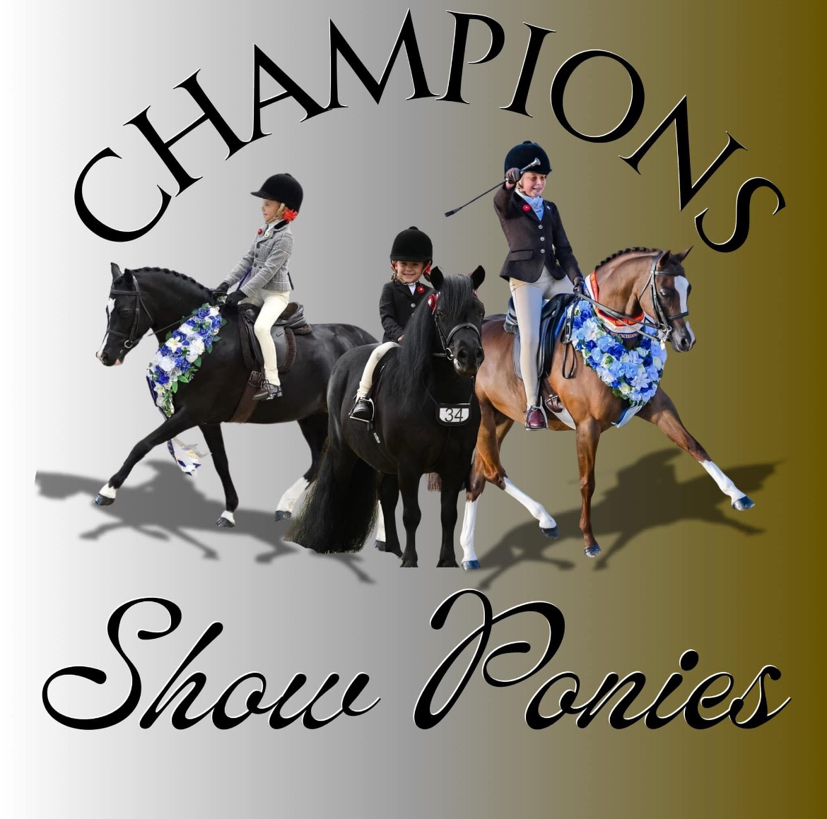
JUNIOR RIDER
Class 7218 Rider 9 years and under
Class 7219 Rider 10 years and under 13 years
CHAMPION JUNIOR RIDER
RESERVE CHAMPION JUNIOR RIDER
**Sponsored by Champion Show Ponies**

SHOW HUNTER HACK
Class 7220 Open Show Hunter Hack over 15hh ne 15.2hh
Class 7221 Open Show Hunter Hack over 15.2hh ne 16hh
Class 7222 Open Show Hunter Hack over 16hh ne 16.2hh
Class 7223 Open Show Hunter Hack over 16.2hh
Class 7224 Lightweight Show Hunter Hack over 15hh ne 16hh
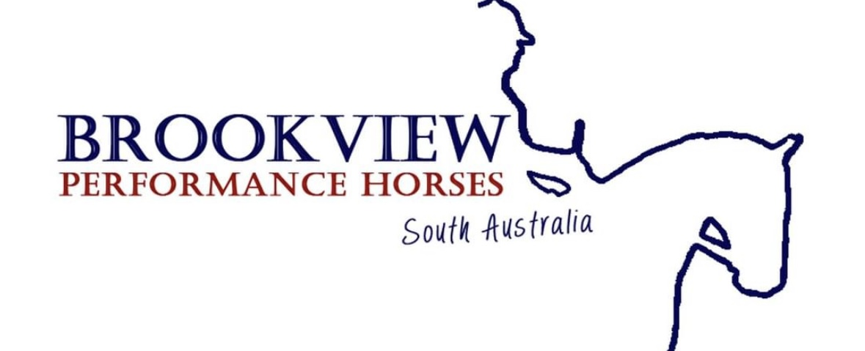
Class 7225 Heavyweight Show Hunter Hack over 15hh ne 16hh
Class 7226 Lightweight Show Hunter Hack over 16hh
Class 7227 Heavyweight Show Hunter Hack over 16hh
Class 7228 Show Hunter Hack over 15hh ne 16hh
Class 7229 Show Hunter Hack over 16hh
Class 7230 Childs Show Hunter Hack over 15hh
Class 7231 Ladies Show Hunter Hack over 15hh
Class 7232 Gentleman's Show Hunter Hack over 15hh
Class 7233 Open Show Hunter Hack over 15hh
CHAMPION SHOW HUNTER HACK
RESERVE CHAMPION SHOW HUNTER HACK
**Sponsored by Brookview Performance Horses**

SHOW HUNTER GALLOWAY
Class 7234 Open Show Hunter Galloway over 14hh ne 14.2hh
Class 7235 Open Show Hunter Galloway over 14.2hh ne 15hh
Class 7236 Lightweight Show Hunter Galloway over 14hh ne 14.2hh
Class 7237 Heavyweight Show Hunter Galloway over 14hh ne 14.2hh
Class 7238 Lightweight Show Hunter Galloway over 14.2hh ne 15hh
Class 7239 Heavyweight Show Hunter Galloway over 14.2hh ne 15hh
Class 7240 Childs Show Hunter Galloway over 14hh ne 15hh
Class 7241 Ladies Show Hunter Galloway over 14hh ne 15hh
Class 7242 Gentleman's Show Hunter Galloway over 14hh ne 15hh
Class 7243 Open Show Hunter Galloway over 14hh ne 15hh
CHAMPION SHOW HUNTER GALLOWAY
RESERVE CHAMPION SHOW HUNTER GALLOWAY
**Sponsored by Oakbank Farm**

INTERMEDIATE RIDER
Class 7244 Rider 13 years and under 15 years
Class 7245 Rider 15 years and under 18 years
CHAMPION INTERMEDIATE RIDER
RESERVE CHAMPION INTERMEDIATE RIDER
**Sponsored by Oakbank Farm**

**SUPREME RIDDEN EXHIBIT**
**Sponsored by Denis Fenwick & Trudy Sims**
(Will be Judged on Completion of ring 1 & 2)
Sash & Gear Bag for Supreme Ridden Exhibit

*********************************************************
* THANK YOU *
The H-I-A Committee of the Balaklava Show wish to thank all their Sponsors that help to keep this show going.
We would also like to thank the Judges and their Stewards who do a wonderful job
*********************************************************
RING 3 - BREED RING
RIDING PONY, A.P.S.B, WELSH PONY & COB SOCIETY, THOROUGHCARE SA PROGRAMS
Ring Starts: 9.00 am

***PLEASE NOTE: Competitors in BREED Rings 3 & 4 maybe asked by RING STEWARD to present MEMBERSHIP CARDS and EXHIBITS REGISTRATION PAPERS for their respective breed classes before they will be allowed to compete.

SUPREME LED EXHIBIT
**Sponsored by Briden Stud**
To be judged from Supreme Championship Winners in Ring 3 & 4

RIDING PONY STUD BOOK SOCIETY
Proudly Sponsored by Riding Pony Stud Book Society- S.A. Branch
Judge: Lia Blacket

All Riding Ponies must be shown in accordance with Rules and Regulations of the Riding Pony Stud Book Society Ltd..
All Ponies must be correctly registered. All Owners and Handlers must be current financial Members. In any one season a pony 4 years & over may be exhibited as a Show Pony or Show Hunter Pony but not as both.

LED YOUNGSTOCK
Class 7301 Led Colt 3 years and under (1yr ne 13.3hh, 2yr ne 14hh, 3yr ne 14.1hh)
Class 7302 Led Filly 3 years and under (1yr ne 13.3hh, 2yr ne 14hh, 3yr ne 14.1hh)
Class 7303 Led Gelding 3 years and under (1yr ne 13.3hh, 2yr ne 14hh, 3yr ne 14.1hh)
CHAMPION LED YOUNGSTOCK
RESERVE CHAMPION LED YOUNGSTOCK

LED SHOW PONY
Class 7304 Led Show Pony 4 years and over ne 13hh
Class 7305 Led Show Pony 4 years and over 13hh ne 14.2hh
CHAMPION LED SHOW PONY
RESERVE CHAMPION LED SHOW PONY
LED SHOW HUNTER PONY
Class 7306 Led Show Hunter Pony 4 years and over ne 13hh
Class 7307 Led Show Hunter Pony 4 years and over 13hh ne 14.2hh
CHAMPION LED SHOW HUNTER PONY
RESERVE CHAMPION LED SHOW HUNTER PONY
*SUPREME CHAMPION LED RIDING PONY*

NEWCOMER RIDING PONY
Class 7308 Newcomer Ridden Pony ne 13.2hh
Class 7309 Newcomer Ridden Pony 13.2hh ne 14.2hh (3yrs ne 14.1hh)
CHAMPION NEWCOMER RIDING PONY
RESERVE CHAMPION NEWCOMER RIDING PONY

RIDDEN SHOW PONY
Class 7310 Ridden Show Pony ne 13hh
Class 7311 Ridden Show Pony over 13hh ne 14.2hh (3yrs ne 14.1hh)
CHAMPION RIDDEN SHOW PONY
RESERVE CHAMPION RIDDEN SHOW PONY

RIDDEN SHOW HUNTER PONY
Class 7312 Ridden Show Hunter Pony ne 13hh
Class 7313 Ridden Show Hunter Pony over 13hh ne 14.2hh (3yrs ne 14.1hh)
CHAMPION RIDDEN SHOW HUNTER PONY
RESERVE CHAMPION RIDDEN SHOW HUNTER PONY

*SUPREME CHAMPION RIDDEN RIDING PONY*

OVER HEIGHT SHOW HACKS & SHOW HUNTER HACKS
Mares or Geldings showing in the Overheight classes must not be shown in any other Riding Pony classes including any Championship or Supreme.
Class 7314 Led Colt 3 years and under (1yr over 13.3hh, 2yr over 14hh, 3yr over 14.1hh)
Class 7315 Led Filly 3 years and under (1yr over 13.3hh, 2yr over 14hh, 3yr over 14.1)
Class 7316 Led Gelding 3 years and under (1yr over 13.3hh, 2yr over 14hh, 3yr over 14.1hh)
CHAMPION LED RPSBS OVERHEIGHT YOUNGSTOCK
RESERVE CHAMPION LED RPSBS OVERHEIGHT YOUNGSTOCK

LED MARE OR GELDING RPSBS OVERHEIGHT OVER 4 YEARS
Mares or Geldings showing in the Over height classes must not be shown in any other Riding Pony classes including any Championship or Supreme.
Class 7317 Led RPSBS Overweight Show Hack Mare or Gelding over 4 years, over 14.2hh
Class 7318 Led RPSBS Overweight Show Hunter Mare or Gelding over 4 years, over 14.2hh
CHAMPION LED MARE OR GELDING RPSBS OVERHEIGHT OVER 4 YEARS
RESERVE CHAMPION LED MARE OR GELDING RPSBS OVERHEIGHT OVER 4

RIDDEN MARE OR GELDING OVERHEIGHT HACK
Mares or Geldings showing in the Over height classes must not be shown in any other Riding Pony classes including any Championship or Supreme.
Class 7319 Ridden Overheight Show Hack Mare or Gelding, 3 years and over, over 14.2hh
Class 7320 Ridden Overheight Show Hunter Hack Mare or Gelding, 4 years and over,
over 14.2hh (3yrs over 14.1hh)
CHAMPION RIDDEN MARE OR GELDING OVERHEIGHT HACK
RESERVE CHAMPION RIDDEN MARE OR GELDING OVERHEIGHT HACK
RING 3 - BREED RING
AUSTRALIAN PONY STUD BOOK – General Program
Proudly Sponsored by Australia Pony Stud Book - S.A.
Judge: Lia Blacket

RULES AND REGULATIONS of the AUSTRALIAN PONY STUD BOOK SOCIETY apply, importantly
• All ponies must be entered in the name of the registered owner or lease, who must be a financial member of the
APSB Society Inc. It is not necessary for the exhibitor (handler, rider or driver) to be a financial member.
• All ponies must be registered with the APSB Society.
• All presentation must be in accordance with the individual breed standard as outlined by the APSB Society.

Junior Classes (17 years and under)
Class 7321 Best Presented APSB Open Pony & APSB Junior Handler, 17 years and under
Class 7322 APSB Child Handler, 10 years and Under
Class 7323 APSB Child Handler, 11 years -17 years
CHAMPION CHILD HANDLER
RESERVE CHAMPION CHILD HANDLER

Adult Classes (18 years and over)
Class 7324 Best Presented APSB Pony & Handler, 18 years and over
Class 7325 APSB Adult Handler, 18 years - 39 years
Class 7326 APSB Adult Handler, 40 years and Over
CHAMPION ADULT HANDLER
RESERVE CHAMPION ADULT HANDLER

Shetland Ponies must not exceed 10.2 hands high
Class 7327 APSB Shetland Pony Junior 1 year
Class 7328 APSB Shetland Pony Junior 2- 3 years
Class 7329 APSB Shetland Pony Mare 4 years and over
Class 7330 APSB Shetland Pony Gelding 4 years and over
Class 7331 APSB Shetland Pony Stallion 4years and over
CHAMPION SHETLAND PONY
RESERVE CHAMPION SHETLAND PONY

Australian Ponies must not exceed 14 hands high
Class 7332 APSB Australian Pony Junior 1 year
Class 7333 APSB Australian Pony Junior 2-3 years
Class 7334 APSB Australian Pony Mare 4 years and over
Class 7335 APSB Australian Pony Gelding 4 years and over
Class 7336 APSB Australian Pony Stallion 4 years and over
Class 7337 Third Generation APSB Australian Pony
CHAMPION AUSTRALIAN PONY
RESERVE CHAMPION AUSTRALIAN PONY

Welsh Mountain Ponies must not exceed 12 hands high
Class 7338 APSB Welsh Mountain Pony Junior 1 year
Class 7339 APSB Welsh Mountain Pony Junior 2-3 years
Class 7340 APSB Welsh Mountain Pony Mare 4 years and over
Class 7341 APSB Welsh Mountain Pony Gelding 4 years and over
Class 7342 APSB Welsh Mountain Pony Stallion 4 years and over
CHAMPION WELSH MOUNTAIN PONY
RESERVE CHAMPION WELSH MOUNTAIN PONY
Welsh B Ponies must not exceed 13.2 hands high
Class 7343 APSB Welsh B Pony Junior 1 year
Class 7344 APSB Welsh B Pony Junior 2- 3 years
Class 7345 APSB Welsh B Pony Mare 4 years and over
Class 7346 APSB Welsh B Pony Gelding 4 years and over
Class 7347 APSB Welsh B Pony Stallion 4 years and over
CHAMPION WELSH B PONY
RESERVE CHAMPION WELSH B PONY

Welsh C or D Ponies - Welsh C must not exceed 13.2 hands high, Welsh D must be over 13.2hands high
Class 7348 APSB Welsh C or D Pony Junior 1 year
Class 7349 APSB Welsh C or D Pony Junior 2-3 years
Class 7350 APSB Welsh C or D Pony Mare 4 years and over
Class 7351 APSB Welsh C or D Pony Gelding 4 years and over
Class 7352 APSB Welsh C or D Pony Stallion 4 years and over
CHAMPION WELSH PONY C or D
RESERVE CHAMPION WELSH PONY C or D

Connemara, Dartmoor, Fjord, Fell, Hackney, Highland, New Forrest
Class 7353 APSB Any Other Purebred Junior 1 year
Class 7354 APSB Any Other Purebred Junior 2-3 years
Class 7355 APSB Any Other Purebred Mare 4 years and over
Class 7356 APSB Any Other Purebred Gelding 4 years and over
Class 7357 APSB Any Other APSB Purebred Stallion 4 years and over
CHAMPION ANY OTHER PUREBRED
RESERVE CHAMPION ANY OTHER PUREBRED

**SUPREME LED PUREBRED APSB EXHIBIT**

APSB Registries
Class 7358 APSB Partbred, any sex, any age
Class 7359 APSB Gypsy Cob or Part- Bred Gypsy Cob, any sex, any age
Class 7360 APSB Riding Pony, any sex, any age
Class 7361 APSB Timor Pony, any sex, any age
CHAMPION REGISTRY
RESERVE CHAMPION REGISTRY

South Australian Bred Ponies - the pony must be bred in South Australia by a resident APSB member breeder
Class 7362 SA Bred Shetland Pony, any sex, any age
Class 7363 SA Bred Australian Pony, any sex, any age
Class 7364 SA Bred Welsh Pony, any sex, any age
Class 7365 SA Bred Any Other Purebred Pony, any sex, any age
Class 7366 SA Bred Registry Pony
CHAMPION SOUTH AUSTRALIAN BRED PONY
RESERVE CHAMPION SOUTH AUSTRALIAN BRED PONY

Child's Ridden Pony Classes
Class 7367 APSB Leading Rein Pony (Rider 5-8years, Pony ne 12.2hh)
Class 7368 APSB First Ridden Pony (Rider under 5 years - 11 years, Pony ne 12.2hh)
Class 7369 APSB Child's Ridden Pony (Rider under 18 years)
CHAMPION CHILD'S PONY
RESERVE CHAMPION CHILD'S PONY

Ridden Pony Classes
Class 7370 APSB Ridden Shetland Pony
Class 7371 APSB Ridden Australian Pony
Class 7372 APSB Ridden Welsh (A-D) Pony
Class 7373 APSB Ridden Any Other Purebred Pony
Class 7374 APSB Ridden Registry Pony
CHAMPION RIDDEN ASPB PONY
RESERVE CHAMPION RIDDEN ASPB PONY

RING 3 - BREED RING
WELSH PONY & COB SOCITEY- 2025/2026
Proudly Sponsored by Welsh Pony & Cob Society of Australia – SA Regional Promotional Group
Judge: Lia Blacket

Welsh Pony & Cob Society of Australia – SA Regional Promotional Group – Run under WPCS Rules. Ponies must be registered with WPCS & Owners financial members. Exhibitors do not have to be financial members so long as the exhibit is registered and owned by the financial member. WHIPS, either led or ridden, length not to exceed 75cm.

HANDLERS
Class 7375 Junior Handler 4-7 yrs, 4 & 5 yrs - MUST be accompanied by an adult.
Class 7376 Junior Handler 6 & 7 yrs - MAY be accompanied by Adult.
Class 7377 Junior Handler 8-11 yrs.
BEST JUNIOR HANDLER UNDER 12 YEARS.

Class 7378 Junior Handler 12, 13 & 14 yrs.
Class 7379 Junior Handler 15, 16 & 17 yrs.
BEST JUNIOR HANDLER 12 YRS & UNDER 18 YEARS.

Class 7380 Handler 18 years & over (Stallions Eligible).

WELSH - LED
Class 7381 Welsh Mountain Filly 3yrs & under.
Class 7382 Welsh Mountain Mare 4 yrs & over.
Class 7383 Welsh Mountain Colt or Stallion.
CHAMPION WELSH MOUNTAIN PONY.
RESERVE CHAMPION WELSH MOUNTAIN PONY.

Class 7384 Welsh Pony Filly 3yrs & under.
Class 7385 Welsh Pony Mare 4 yrs & over.
Class 7386 Welsh Pony Colt or Stallion.
CHAMPION WELSH PONY.
RESERVE CHAMPION WELSH PONY.

Class 7387 Welsh Pony of Cob Type Filly 3 yrs & under.
Class 7388 Welsh Pony of Cob Type Mare 4 yrs & over.
Class 7389 Welsh Pony of Cob Type Colt or Stallion.
CHAMPION WELSH PONY OF COB TYPE.
RESERVE CHAMPION WELSH PONY OF COB TYPE.

Class 7390 Welsh Cob Filly 3 yrs & under.
Class 7391 Welsh Cob Mare 4 yrs & over.
Class 7392 Welsh Cob Colt or Stallion.
CHAMPION WELSH COB.
RESERVE CHAMPION WELSH COB.

Class 7393 Welsh Gelding of A Breeding, any age.
Class 7394 Welsh Gelding of B Breeding, any age.
Class 7395 Welsh Gelding of C Breeding, any age.
Class 7396 Welsh Gelding of D Breeding, any age.
CHAMPION WELSH GELDING.
RESERVE CHAMPION WELSH GELDING.
**SUPREME WELSH EXHIBIT**
(Champion Welsh Mountain, Welsh Pony, Welsh Pony of Cob Type, Welsh Cob and Welsh Gelding eligible).

PART WELSH - LED
Class 7397 Part Welsh Colt 3 yrs & under.
Class 7398 Part Welsh Stallion 4 yrs & over.
CHAMPION PART WELSH COLT OR STALLION.
RESERVE CHAMPION PART WELSH COLT OR STALLION.

Class 7399 Part Welsh Filly 3 yrs & under.
Class 7400 Part Welsh Mare ne 13 hh. 4 yrs & over.
Class 7401 Part Welsh Mare over 13 hh. 4 yrs & over.
CHAMPION PART WELSH FILLY OR MARE.
RESERVE CHAMPION PART WELSH FILLY OR MARE.

Class 7402 Part Welsh Gelding 3 yrs & under.
Class 7403 Part Welsh Gelding ne 13 hh. 4 yrs & over.
Class 7404 Part Welsh Gelding over 13 hh. 4 yrs & over.
CHAMPION PART WELSH GELDING.
RESERVE CHAMPION PART WELSH GELDING.

**SUPREME PART WELSH**
(Champion PW Colt/Stallion, PW Filly/Mare and PW Gelding eligible).

LEAD REIN/FIRST RIDDEN:
Class 7405 Welsh Leading Rein Pony 12hh & under, Rider 3 yrs & under 8 yrs
(NOT eligible for classes 7407 & 7408)
Class 7406 Welsh First Ridden Pony Rider 12.2hh & under, Rider 5yrs & under 12 yrs.
(NOT eligible for classes 7407 & 7408)
CHAMPION WELSH LEADING REIN/FIRST RIDDEN PONY.
RESERVE CHAMPION WELSH LEADING REIN/FIRST RIDDEN PONY.

Class 7407 Open Leading Rein Pony 12hh & under, Rider 3 yrs & under 8 yrs P/W Eligible
(NOT eligible for classes 7405 & 7408)
Class 7408 Open First Ridden Pony 12.2hh & under, Rider 5yrs & under 12 yrs P/W Eligible
(NOT eligible for classes 7405 & 7408)
CHAMPION OPEN LEADING REIN/FIRST RIDDEN PONY.
RESERVE CHAMPION OPEN LEADING REIN/FIRST RIDDEN PONY.

CHILDS RIDER CLASSES
Class 7409 Child Rider under 10 years - may be led.
Class 7410 Child Rider 10 years & under 15 years.
Class 7411 Child Rider 15 years & under 18 years.

CHILDS WELSH RIDDEN
Riders to be 5 yrs and under 18 yrs. Ponies must be ridden in a snaffle bit. No spurs.
(Mounts in Classes 7412, 7413, 7414 & 7415 NOT eligible for classes 7416, 7417, 7418 & 7419)
Class 7412 Child's Ridden Welsh Mare, Filly, Gelding, over 13.2hh. Riders 5 years
and under 18 yrs.
Class 7413 Child's Ridden Welsh Mare, Filly, Gelding, over 12hh and ne 13.2hh. Riders
Riders 5 yrs and under 18 yrs
Class 7414 Child's Ridden Welsh Mare, Filly, Gelding, 12hh & Under. Riders under 12 yrs.
Class 7415 Child's Ridden Welsh Mare, Filly, Gelding, 12hh & Under. Riders 12 years and under 18 yrs.
CHAMPION RIDDEN WELSH CHILD'S PONY.
RESERVE CHAMPION RIDDEN WELSH CHILD'S PONY.

CHILDS RIDDEN OPEN
Riders to be 5 yrs and under 18 yrs. Ponies must be ridden in a snaffle bit. No spurs.
(Mounts in Classes 7416, 7417, 7418 & 7419 NOT eligible for classes 7412, 7413, 7414 & 7415)
Class 7416 Child's Ridden Open Mare, Filly, Gelding, over 13hh.
Riders 5 yrs and Under 18 years. (P/W Eligible).
Class 7417 Child's Ridden Open Mare, Filly, Gelding, over 12hh & ne 13hh.
Riders 5 yrs and Under 18 years. (P/W Eligible).
Class 7418 Child's Ridden Open Mare, Filly, Gelding, 12hh & Under.
Rider under 12 years. (P/W Eligible).
Class 7419 Child's Ridden Open Mare, Filly, Gelding, 12hh & Under. Rider 12 -18 yrs
Riders 12 yrs and Under 18 years. (P/W Eligible).
CHAMPION & RESERVE OPEN RIDDEN CHILD'S PONY.
RESERVE CHAMPION OPEN RIDDEN CHILD'S PONY.

RIDDEN WELSH:
Class 7420 Ridden Welsh Mountain Mare/Gelding.
Class 7421 Ridden Welsh Pony Mare/Gelding.
Class 7422 Ridden Welsh Pony of Cob Type Mare/Gelding.
Class 7423 Ridden Welsh Cob Mare/Gelding.
Class 7424 Ridden A, B, C or D Stallion 3 yrs & over.
CHAMPION RIDDEN WELSH.
RESERVE CHAMPION RIDDEN WELSH.

RIDDEN PART WELSH:
Class 7425 Part-Welsh Ridden Mare/Gelding ne 12.2hh.
Class 7426 Part-Welsh Ridden over 12.2hh & ne 13.2hh.
Class 7427 Part-Welsh Ridden Mare/Gelding over 13.2.
Class 7428 Part-Welsh Ridden Stallion 3yrs & over.
CHAMPION RIDDEN PART-WELSH.
RESERVE CHAMPION RIDDEN PART-WELSH.
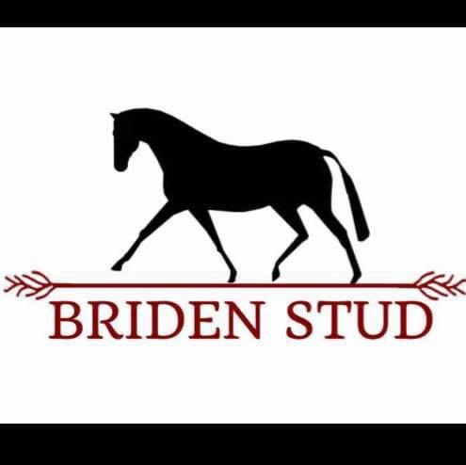
**SUPREME LED EXHIBIT**
**Sponsored by Briden Stud**
(On Completion of Rings 3 & 4)
To be judged from Supreme Championship Winners in Ring 3 & 4
Sash & Gear Bag for Supreme Led Exhibit

RING 3- BREED RING
ThoroughCare SA
Proudly Sponsored by ThoroughCare SA
Judge: Lia Blacket

Eligibility-All thoroughbreds registered with the Australian Thoroughbred Studbook and bred for the purpose of racing, including imported thoroughbreds and those who have not trialed or raced are eligible to compete in South Australia "Bred to Race" classes, events and awards. "Eligibility will be checked through the Registrar of Racehorses, or international equivalents prior to competition.

LED CLASSES
Class 7429 Best Presented Led Thorough Care SA exhibit any height (not eligible for Champion)
Class 7430 Led Thorough Care SA Newcomer Show Horse, any height
Class 7431 Led Thorough Care SA Show Horse ne 16hh
Class 7432 Led Thorough Care SA Show Horse 16hh & over
Class 7433 Led Thorough Care SA Show Horse Mare, any height
Class 7434 Led Thorough Care SA Show Horse Gelding, any height
CHAMPION TCSA LED THOROUGHBRED SHOW HORSE
RESERVE CHAMPION TCSA LED THOROUGHBRED SHOW HORSE

HUNTER LED CLASSES
Class 7435 Led Thorough Care SA Newcomer Show Hunter, any height
Class 7436 Led Thorough Care SA Show Hunter ne 16hh
Class 7437 Led Thorough Care SA Show Hunter 16hh & Over
Class 7438 Led Thorough Care SA Show Hunter Mare, any height
Class 7439 Led Thorough Care SA Show Hunter Gelding, any height
Class 7440 Led Thorough Care SA Show Hunter
CHAMPION TCSA LED THOROUGHBRED SHOW HUNTER
(Champion eligible for Supreme led TCSA exhibit)
RESERVE CHAMPION TCSA LED THOROUGHBRED SHOW HUNTER
(Champion eligible for supreme led TCSA exhibit)

HANDLER CLASSES
Class 7441 Handler under 18yrs
Class 7442 Handler 18yrs & over
CHAMPION TCSA HANDLER
RESERVED CHAMPION TCSA HANDLER

SHOW HORSE RIDDEN
Class 7443 Smartest on Parade Thorough Care SA Hack exhibit
Class 7444 Ridden Thorough Care SA Newcomer Show Horse, any height
Class 7445 Ridden Thorough Care SA Show Horse ne 16hh
Class 7446 Ridden Thorough Care SA Show Horse 16hh & over
Class 7447 Lightweight Ridden Thorough Care SA Show Horse, any height
Class 7448 Heavyweight Ridden Thorough Care SA Show Horse, any height
Class 7449 Ridden Mare Thorough Care SA Show Horse, any height
Class 7450 Ridden Gelding Thorough Care SA Show Horse, any height
Class 7451 Ladies Ridden Thorough Care SA Show Horse, any height
Class 7452 Gentleman's Ridden Thorough Care SA Show Horse, any height
Class 7453 Educated Ridden Thorough Care SA Show Horse ne 16hh
Class 7454 Educated Ridden Thorough Care SA Show Horse 16hh & Over
Class 7455 Pleasure Ridden Thorough Care SA Show Horse ne 16hh
Class 7456 Pleasure Ridden Thorough Care SA Show Horse 16hh & over
RESERVE CHAMPION TCSA THOROUGHBRED SHOW HORSE
(Champion eligible for supreme Ridden TCSA exhibit)
CHAMPION TCSA THOROUGHBRED SHOW HORSE
(Champion eligible for Supreme TCSA exhibit)

SHOW HUNTER
Class 7457 Smartest on Parade Thorough Care SA Hunter exhibit
Class 7458 Ridden Thorough Care SA Newcomer Show Hunter, any height
Class 7459 Ridden Thorough Care SA Show Hunter Horse ne 16hh
Class 7460 Ridden Thorough Care SA Show Hunter Horse 16hh & over
Class 7461 Lightweight Ridden Thorough Care SA Show Hunter Horse, any height
Class 7462 Heavyweight Ridden Thorough Care SA Show Hunter Horse, any height
Class 7463 Ridden Mare Thorough Care SA Show Horse, any height
Class 7464 Ridden Gelding Thorough Care SA Show Horse, any height
Class 7465 Ladies Ridden Thorough Care SA Show Hunter Horse, any height
Class 7466 Gentleman's Ridden Thorough Care SA Show Hunter Horse, any height
Class 7467 Educated Ridden Thorough Care SA Show Hunter Horse ne 16hh
Class 7468 Educated Ridden Thorough Care SA Show Hunter Horse 16hh & over
Class 7469 Pleasure Ridden Thorough Care SA Show Hunter Horse ne 16hh
Class 7470 Pleasure Ridden Thorough Care SA Show Hunter Horse 16hh & over
CHAMPION TCSA THOROUGH SHOW HUNTER HORSE
(Champion eligible for supreme Ridden TCSA exhibit)
RESERVE CHAMPION TCSA THOROUGHBRED SHOW HUNTER HORSE
(Champion eligible for Supreme Ridden TCSA exhibit)

RIDER CLASSES
Class 7471 Novice Rider, any age
Class 7472 Rider 14yrs-18yrs
Class 7473 Rider 18yrs-21 yrs
Class 7474 Rider 21yrs-30yrs
Class 7475 Rider 30yrs & over
CHAMPION THOROUGH CARE SA RIDER
RESERVE CHAMPION THOROUGH CARE SA RIDER

RING 4 - BREED RING
MINIATURE PONY, PINTO, OPEN BREEDS & ARABS PROGRAMS
Ring Starts: 9.00 am

***PLEASE NOTE: Competitors in BREED Rings 3 & 4 maybe asked by RING STEWARD to present MEMBERSHIP CARDS and EXHIBITS REGISTRATION PAPERS for their respective breed classes before they will be allowed to compete.

**SUPREME LED EXHIBIT**
*Sponsored by Briden Stud*
(On completion of Ring 3 & 4)
To be judged from Supreme Championship Winners in Ring 3&4
Sash & Gear Bag for Supreme Led Exhibits

THE AUSTRALIAN MINIATURE PONY SOCIETY INC. – SA PROMOTIONAL GROUP
2025/2026 HIGH POINT CLASSES
Proudly Sponsored by The Australian Miniature Pony Society Inc – SA Promotional Group
Judge: Sandra Mac

All Shows that are High Point Shows are confirmed as such on the Programme/Calendar of Events.
* All Exhibits must be registered with the Australian Miniature Pony Society Inc and in the name of a current financial Member.
* All Exhibits must be prepared in accordance with the Australian Miniature Pony Society Inc Standard of Showing.
* All Handlers must be current Financial members of Australian Miniature Pony Society Inc, including Junior Handlers
who must be current financial Members in their own right, either as a Junior Member or as part of a Joint or Family Membership.
* Handlers: Age applies at first day of current show season. All Handlers stay in same age class all season, irrespective if birthday is during season.
* Show Entries MUST be submitted by the OWNER of the Pony, unless written permission is given by the owner of the Pony for someone else to submit the entries.
* Show Entries MUST be submitted in the name of the AMPS Member, NOT the Stud name as they are not recognized by the Society as being the Member.
* Names of Ponies MUST be used in full, as they are recorded in the data base and on the Registration Certificate, not shortened.
* Appendix Pony Classes: Ponies with current “Appendix” Registration Certificates eligible to enter.
** Note: If your Pony measures over 87cm & you accept measurement, you can show on the day: see below.

LED MINIATURE PONY EXHIBIT
Class 7500 Best Presented Miniature Pony & Junior Handler *(No Workout)
Class 7501 Best Presented Miniature Pony & Adult Handler *(No Workout)

Class 7502 Filly 1 year and under
Class 7503 Filly 2 years
Class 7504 Mare 3 years to 7 years
Class 7505 Mare 8 years and over
CHAMPION MINIATURE MARE/FILLY
RESERVE CHAMPION MINIATURE MARE/FILLY

Class 7506 Colt 1 year and under
Class 7507 Colt 2 years
Class 7508 Stallion 3 years to 7 years
Class 7509 Stallion 8 years and over
CHAMPION MINIATURE STALLION/COLT
RESERVE CHAMPION MINIATURE STALLION/COLT

Class 7510 Gelding 1 year and under
Class 7511 Gelding 2 years
Class 7512 Gelding 3 year to 7 years
Class 7513 Gelding 8 years and over
CHAMPION MINIATURE GELDING
RESERVE CHAMPION MINIATURE GELDING
*SUPREME LED MINIATURE PONY EXHIBIT*
(Eligible for Supreme: Champion Mare/Filly, Champion Colt/Stallion, Champion Gelding)

LED MINIATURE PONY HANDLER
Class 7514 Novice Handler - any Age
(Those Eligible-anyone not having won an AMPS Handler Class)
**Kindly Note-Winner of Novice Handler NOT eligible to go in for Champion Handler**

Class 7515 Junior Handler 9 years and under
Class 7516 Junior Handler 10 to 14 years
Class 7517 Junior Handler 15 to 17 years
CHAMPION CHILD HANDLER
RESERVE CHAMPION CHILD HANDLER

Class 7518 Adult Handler 18 years to 30 years
Class 7519 Adult Handler 31 years to 46 years
Class 7520 Adult Handler 47 years to 66 years
Class 7521 Adult Handler 67 years and over
CHAMPION ADULT HANDLER
RESERVE CHAMPION ADULT HANDLER

Class 7522 Hand Led-Miniature Pony Ridden Class *Rider MUST wear Approved Helmet*
Class 7523 Long Reign-Miniature Pony Class *Handler MUST wear Approved Helmet*

Appendix Pony Classes *These Classes CANNOT be combined with Miniature Classes above*
Class 7524 Best Presented Appendix Pony and Junior Handler *(No Workout)
Class 7525 Best Presented Appendix Pony and Adult Handler *(No Workout)

Class 7526 Appendix Filly 2 years and under
Class 7527 Appendix Mare 3 years and over
CHAMPION APPENDIX FILLY/MARE
RESERVE CHAMPION APPENDIX FILLY/MARE

Class 7528 Appendix Colt 2 years and under
Class 7529 Appendix Stallion 3 years and over
CHAMPION APPENDIX COLT/STALLION
RESERVE CHAMPION APPENDIX COLT/STALLION

Class 7530 Appendix Gelding 2 years and under
Class 7531 Appendix Gelding 3 years and over
CHAMPION APPENDIX GELDING
RESERVE CHAMPION APPENDIX GELDING
*SUPREME APPENDIX PONY*
(Eligible for Supreme: Champion Appendix Filly/Mare, Champion Appendix Colt/Stallion, Champion Appendix Gelding)

Class 7532 Novice Handler - Any Age (Eligible – Anyone not having won an AMPS Handler Class)
Class 7533 Junior Handler 9 years and Under
Class 7534 Junior Handler 10 years to 14 years
Class 7535 Junior Handler 15 years to 17 years
CHAMPION CHILD HANDLER - APPENDIX PONY
RESERVE CHAMPION CHILD HANDLER - APPENDIX PONY

Class 7536 Adult Handler 18 years to 25 years
Class 7537 Adult Handler 26 years to 50 years
Class 7538 Adult Handler 51 years and over
CHAMPION ADULT HANDLER - APPENDIX PONY
RESERVE CHAMPION ADULT HANDLER - APPENDIX PONY

Class 7539 Hand Led - Appendix Pony Ridden Class *Rider MUST wear Approved Helmet*
Class 7540 Long Reign - Appendix Pony Class *Handler MUST wear Approved Helmet*

*** Please note: We have a procedure in place whereby any Pony who officially measures over 87cm at a Show and the Member accepts the measurement; the Pony can be shown in the Appendix section on that day and the Pony’s Registration Certificate must be surrendered on the day and / or returned to the office within 28 days to be upgraded to Appendix. Failure to return the Registration Certificate to the office by the specified date, will result in the Pony being de-registered.

**SUPREME LED EXHIBIT**
*Sponsored by Briden Stud*
(On completion of Ring 3 & 4)
To be judged from Supreme Championship Winners in Ring 3&4
Sash & Gear Bag for Supreme Led Exhibits

RING 4 - BREED RING
PINTO’S - 2025/2026 PROGRAM

Proudly Sponsored by Independent Pinto Horse Society Inc - Australia
Judge: Sandra Mac

Pintos must be Registered with an Incorporated Pinto Society/Association, all Owners and Handlers must be Financial Members of an Incorporated Pinto Society/Association. Proof of current Registration and Membership may be requested.

LED PINTO
Class 7541 Best Presented Pinto & Handler.
Class 7542 Best Marked Pinto.
Class 7543 Led Colt - 3 years & under
Class 7544 Led Stallion - 4 years & over
CHAMPION PINTO STALLION OR COLT - Sashes sponsored by IPHS.
RESERVE CHAMPION PINTO STALLION OR COLT

Class 7545 Led Filly - 3 years & under.
Class 7546 Led Mare - 4 years & over.
CHAMPION PINTO MARE OR FILLY - Sashes sponsored by IPHS.
RESERVE CHAMPION PINTO MARE OR FILLY

Class 7547 Led Gelding - 3 years & under.
Class 7548 Led Gelding - 4 years & over.
CHAMPION PINTO GELDING- Sashes sponsored by IPHS.
RESERVE CHAMPION PINTO GELDING

* SUPREME CHAMPION LED PINTO EXHIBIT*
Sash sponsored by IPHS

Class 7549 Youth Handler 5 - 17 years.
Class 7550 Open Handler 18 years & over.

RIDDEN PINTO
Class 7551 Pinto under Saddle - Stallion.
Class 7552 Pinto under Saddle - Mare.
Class 7553 Pinto under Saddle - Gelding.
CHAMPION PINTO UNDER SADDLE- Sashes sponsored by IPHS.
RESERVE CHAMPION PINTO UNDER SADDLE

Class 7554 Youth Bridle Path Hack.
Class 7555 Junior Pinto Bridle Path Hack.
Class 7556 Senior Pinto Bridle Path Hack.

RING 4 – BREED RING
OPEN BREED CLASSES
Judge: Sandra Mac
For Registered and unregistered horses

Class 7557 Led Filly 3 years and under, any height
Class 7558 Led Mare 4 years and over, any height
CHAMPION OPEN LED FILLY/MARE
RESERVE CHAMPION OPEN LED FILLY/MARE

Class 7559 Led Colt 3 years and under, any height
Class 7560 Led Stallion 4 years and over, any height
CHAMPION OPEN LED COLT/STALLION
RESERVE CHAMPION OPEN LED COLT/STALLION

Class 7561 Led Gelding 3 years and under, any height
Class 7562 Led Gelding 4 years and over, any height
CHAMPION OPEN LED GELDING
RESERVE CHAMPION OPEN LED GELDING

*SUPREME OPEN LED EXHIBIT*

Class 7563 Ridden Mare ne 14.2hh
Class 7564 Ridden Mare over 14.2hh
CHAMPION OPEN RIDDEN MARE
RESERVE CHAMPION OPEN RIDDEN MARE

Class 7565 Ridden Stallion ne 14.2hh
Class 7566 Ridden Stallion over 14.2hh
CHAMPION OPEN RIDDEN STALLION
RESERVE CHAMPION OPEN RIDDEN STALLION

Class 7567 Ridden Gelding ne 14.2hh
Class 7568 Ridden Gelding over 14.2hh
CHAMPION OPEN RIDDEN GELDING
RESERVE CHAMPION OPEN RIDDEN GELDING

*SUPREME OPEN RIDDEN EXHIBIT*

RING 4-BREED RING
Arabs SA
Proudly Sponsored by Arabs SA
Judge: Sandra Mac

LED CLASSES
Class 7569 Youth Handler, showing a Purebred, Derivative or API
Class 7570 Classic Head, Purebred
Class 7571 Classic Trot, Purebred
Class 7572 Purebred Mare 4yrs & over
Class 7573 Purebred Filly 3yrs & under
Class 7574 Purebred Gelding 4yrs & over
Class 7575 Purebred Gelding 3yrs & under
Class 7576 Purebred Colt or Stallion
CHAMPION PUREBRED ARAB
RESERVE CHAMPION PUREBRED ARAB

Class 7577 Best Handler 18yrs & over, showing a purebred, Derivative or API
Class 7578 Quality Head-Derivative
Class 7579 Quality Trot-Derivative
Class 7580 Led Arabian Derivative 3yrs & under, any sex
Class 7581 Led Arabian Derivative over 3yrs,ne 12.2hh (Male)
Class 7582 Led Arabian Derivative over 3yrs, over 14.2hh (Female)
CHAMPION ARABIAN DERIVATIVE
RESERVE CHAMPION ARABIAN DERIVATIVE

Class 7583 Led API exhibit (Male)
Class 7584 Led API exhibit (Female)
CHAMPION API
RESERVE CHAMPION API
**SUPREME LED ARABIAN**

PUREBRED RIDDEN CLASSES
Class 7585 Purebred Newcomer Hack
Class 7586 Purebred Open Hack
Class 7587 Purebred Bridle Path Hack
CHAMPION PUREBRED HACK
RESERVE CHAMPION PUREBRED HACK

ARABIAN DERIVATIVE RIDDEN CLASSES
Class 7588 Arabian Derivative Newcomer Hack
Class 7589 Arabian Derivative Hack ne 14hh
Class 7590 Arabian Derivative Bridle Path Hack
Class 7591 Arabian Derivative Hack over 14hh ne 15.2hh
Class 7592 Arabian Derivative Hack over 15.2hh
Class 7593 Arabian Derivative Child's Hack (rider under 18yrs)
CHAMPION ARABIAN DERIVATIVE HACK
RESERVE CHAMPION ARABIAN DERIVATIVE HACK

Class 7594 API Hack ne 14.2hh
Class 7595 API Hack over 14.2hh
Class 7596 API Bridle Path Hack
Class 7597 API Child's Hack (rider under 18yrs)
CHAMPION API HACK
RESERVE CHAMPION API HACK

Class 7598 Pleasure Hack (rider under 18yrs) API eligible
Class 7599 Mount most suitable for Pony Club, Youth Rider under 18yrs, API eligible
Class 7600 Western Pleasure, Purebred/Derivative
Class 7601 Show Hunter, Purebred
Class 7602 Show Hunter, Arabian Derivative
Class 7603 Costume (show or native) Purebed/Derivative
**SUPREME LED EXHIBIT**
**Sponsored by Briden Stud**
(On Completion of Ring 3&4)
To be Judged from Supreme Championship Winners in Ring 3&4
Sash & Gear Baag for Supreme Led Exhibit

RING 5 - TOPSY EVENTS
Judge: Janine Kranz
THIS RING IS ALL ABOUT FUN & CONFIDENCE BUILDING
Uniform: Hacking Jackets and Plaiting Not Required. Snaffle Bits only. No Spurs Allowed. No double reins, All competitors to be 12 years or under ‘L’ Classes – Led events: competitors to be accompanied by an adult. Ridden events. Competitors to remain led all day.
L Class competitors ineligible to compete in P Classes. ‘P’ Classes – Competitors to remain unled in all Events. P Class competitors are ineligible to compete in L Classes. Walk/Trot classes are for combinations that are generally not yet able to canter.
STRICTLY – IF YOU COMPETE AS AN “L” PLATER YOU CAN NOT COMPETE AS A “P” PLATER – AND VICE VERSA

‘L’ Classes
Led in classes; unmounted
Class 7700 Handler under 6 years
Class 7701 Handler 6 years and under 10 years
Class 7702 Handler 10 years and to 12 years
Class 7703 Led Pony ne 12.2hh
Class 7704 Led Pony over 12.2hh ne 14hh
Class 7705 Led Galloway/Horse over 14hh

L' Classes - Ridden classes
Class 7706 Ridden Pony ne 12.2hh
Class 7707 Ridden Pony over 12.2hh ne 14hh
Class 7708 Open Pony/Galloway/Hack over 14hh
Class 7709 Quietest Mount any height
Class 7710 Smartest on Parade under 6 years
Class 7711 Smartest on Parade 6 years and under 10 years
Class 7712 Smartest on parade 10 years and to 12 years
Class 7713 Rider under 6 years
Class 7714 Rider 6 years and under 10 years
Class 7715 Rider 10 years and to 12 years
**BEST L PLATE COMBINATION**

THE FOLLOWING CLASSES ARE ELIGIBLE FOR ALL TINY TOT COMPETITORS
Class 7716 Fattest Pony
Class 7717 Hairiest Pony
Class 7718 Longest Tail
Class 7719 Longest Mane
Class 7720 Biggest Smile (child)
Class 7721 Cutest Pony

P' Classes
Led in classes; unmounted
Class 7722 Handler under 6 years
Class 7723 Hander 6 years and under 10 years
Class 7724 Handler 10 years and to 12 years
Class 7725 Led Pony ne 12hh
Class 7726 Led Pony over 12.2hh ne 14hh
Class 7727 Led Galloway/Hack over 14hh

P' Classes - Ridden classes
Class 7728 Walk/Trot Pony ne 12hh
Class 7729 Walk/Trot Pony 12.2hh ne 14hh
Class 7730 Walk/Trot Galloway/Hack over 14hh
Class 7731 Walk/Trot Quietest Mount any height
Class 7732 Walk/Trot Rider under 6 years
Class 7733 Walk/Trot Rider 6 years and under 10 years
Class 7734 Walk/Trot Rider 10 years and to 12 years
Class 7735 Smartest on Parade under 6 years
Class 7736 Smartest on Parade 6 years and under 10 years
Class 7737 Smartest on Parade 10 years and to 12 years
Class 7738 Open Pony ne 12hh
Class 7739 Open Pony over 12.2hh ne 14hh
Class 7740 Open Galloway/Hack over 14hh
Class 7741 Quietest Mount any height
Class 7742 Rider under 6 years
Class 7743 Rider 6 years and under 10 years
Class 7744 Rider 10 years to 12 years
**BEST P PLATE COMBINATION”

RING 5 - ENCOURAGE
Judge: Janine Kranz

Open Classes are for any horse or Pony. Hacking Attire to be worn by Competitors in this Ring. Competitors can present as either a Show Horse or Hunter.

Class 7750 Smartest on Parade (Open)

Class 7751 Rider under 12 years
Class 7752 Rider over 12 years and under 15 years
Class 7753 Rider over 15 years and under 18 years
Class 7754 Rider over 18 years
CHAMPION RIDER
RESERVE CHAMPION RIDER
(Winners from Classes 7751 to 7754)

Class 7755 Maiden Pony ne 14hh
Class 7756 Pony Hack ne 12hh
Class 7757 Pony Hack over 12hh ne13hh
Class 7758 Pony Hack over 13hh ne 14hh
Class 7759 Open Pony ne 14hh
Class 7760 Child's Pony Hack ne 12.2hh, Rider under 12 years
Class 7761 Child's Pony Hack over 12.2hh ne 14hh, Rider under 18 years
CHAMPION PONY NE 14HH
RESERVE CHAMPION PONY NE 14HH

Class 7762 Maiden Galloway Hack over 14hh ne 15hh
Class 7763 Galloway Hack over 14hh ne 14.2hh
Class 7764 Galloway Hack over 14.2hh ne 15hh
Class 7765 Open Galloway Hack over 14hh ne 15hh
Class 7766 Child's Galloway Hack 14hh ne 15hh, Rider under 18 yrs
CHAMPION GALLOWAY HACK
RESERVE CHAMPION GALLOWAY HACK

Class 7767 Maiden Hack over 15hh
Class 7768 Hack over 15hh ne 15.2hh
Class 7769 Hack over 15.2hh ne 16hh
Class 7770 Hack over 16hh ne 16.2hh
Class 7771 Hack over 16.2hh
Class 7772 Open Hack over 15hh
Class 7773 Child's Hack over 15hh, Rider under 18yrs
CHAMPION HACK

RESERVE CHAMPION HACK

SUPREME ENCOURAGE EXIBIT
Sash & $50 Cash Prize
**Sponsored by Performance Saddlefits NSA**

***FANCY DRESS AT COMPLETION OF ALL RINGS***
**OPEN TO ALL COMPETITORS**

