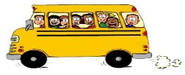

FLOAT PARKING
BALAKLAVA SHOW HIA OVAL MAP
FLOAT PARKING
HORSE GATE TO OVAL
SECRETARY’S OFFICE

CLUBROOMS/ CANTEEN
GRAIN SHED

SIDE SHOw ALLEY

STALLS/TRADE SITES
FIRST AID
TOILETS

FIRST AID
COMMITTEE/ ANNOUNCER
RING 4
RING 3
RING 5
RING 2
RING 1
WARM UP AREA
FLOAT PARKING
ENTERTAINMENT
MARQUEE
SOUTH GATE

PLAYGROUND/
NETBALL COURTS
DISABLED PARKING
NO FLOAT ENTRY
NORTH GATE
FLOAT ENTRY
VIA
WEROCATA ROAD

GRANDSTAND

